

**Softwarica college of IT and E-commerce**

**Coventry University Priory St, Coventry CV1 5FB, UK**

SMART FACTORY

**Group members:**

**Anu Bhattarai**

**Sandesh Malla**

**Samit Bhattarai**

**Abhishek Adhikari**

**Submitted to: Mr Manoj Shrestha**

**Submitted by:**

**Anu Bhattarai**

**Bsc(Hons) in Computing**

Contents

Introduction 4

Aim and Objectives 4

Justification 4

Research and Plan 8

Privacy and Ethics 10

Risk management 11

System Design 11

Working mechanism 16

Development 17

Circuit Diagram 17

Sketch 20

Testing 31

Troubleshooting 32

Future Work 32

Other application 32

Conclusions 33

References 33

Personal challenges 34

**Figure 1(Smart parking problem and solution)** 4

**Figure 2(problem and solution for Smart Fire alert)** 5

**Figure 3(Problem and Solution for smart door)** 5

**Figure 4(problem and solution for smart Light)** 6

**Figure 5(Smart water level monitoring problem and solution)** 6

**Figure 6(Gantt chart for the project)** 8

**Figure 7(Gantt Chart for the project)** 9

**Figure 8(Project Statistics)** 9

**Figure 9:(Risk matrix)** 10

**Figure 10(Risk log)** 10

**Figure 11(Node MCU)** 11

**Figure 12(Arduino Uno)** 11

**Figure 13(LDR)** 12

**Figure 14(Flame Sensor)** 12

**Figure 15(Ultrasonic Sensor)** 12

**Figure 16(Motor)** 13

**Figure 17(Relay)** 13

**Figure 18(RFID)** 14

**Figure 19(Prototype for Smart Factory)** 14

**Figure 20(Dashboard for the Smart Factory)** 14

**Figure 21(Circuit diagram for Smart Water Level Monitoring Systems)** 16

**Figure 22(Circuit Diagram For Smart Parking)** 17

**Figure 23(Circuit diagram for RFID)** 17

**Figure 24(Smart Light)** 18

**Figure 25(Circuit diagram for Fire alert Systems)** 18

**Figure 26(Sketch for Smart Factory)** 19

**Figure 27(Sketch For Smart Factory)** 20

**Figure 29(Sketch for Fire alert)** 21

**Figure 30(Sketch for Fire alert)** 22

**Figure 31(Sketch for MQTT Connection)** 23

**Figure 32( Sketch for LDR)** 24

**Figure 33(Smart Parking)** 25

**Figure 34(Sketch For RFID**) 30

**Figure 35(Other Application)** 32

# Introduction

Smart factory is all about understanding and accepting interconnected new technology to enhance the performance of factory for ensuring the quality of employee and service quality in longer perspective. It is also about monitoring and managing regular activity of the Factory. Data is the most valuable things in the era of the Internet. With the use of various type of sensors that are used for different purpose in the factory such as a RFID for not giving access to unauthorised user in the factory to fire alert systems which give the alert in the form of notification if the sensor detect fire in the factory, data is being collected and these collected data are stored in the adafruit cloud service. These stored data are visualized within adafruit cloud service for better understanding and forecast future values. The data always give the valuable information and that information can be used for avoiding the risk that might occurs in the future. Moreover, the dashboard has been created in the adafruit cloud service for better visualization and analytics purpose. (Deloitte Insights, 2019)

# Aim and Objectives

Project aim is to integrate different Arduino technology and develop a smart prototype for smart factory which will have the feature like the fire alert systems, water level monitoring, RFID, Light automation and parking alert systems which shall be helpful in making a smart decision.

**Objectives**

1. To develop the prototype for making the factory smart.
2. Learn to perform teamwork project to improve coordination and leadership quality.
3. To learn about the Internet of things.
4. To analyse how the sensors, work and their fundamentals.
5. To use the technology for improving the quality of the factory.
6. To manage and monitor the activity of the factory.
7. To build the decision support systems.
8. To build the systems which save time require do that activity with the help of automation.
9. To make the use of valuable information for tackling the problems.
10. To store the collected data to the cloud.

# Justification

In the factory, there occur lots of minor problems and even hazardous trouble in day to day basis that hinders the efficiency of the factory. So, using smart factory solution helps to reduce daily problem and minimize the effects of problem.

According to the scenario, the parking assistance helps drivers to park their vehicles safely and reduce damages of vehicles and even wall of the factory.

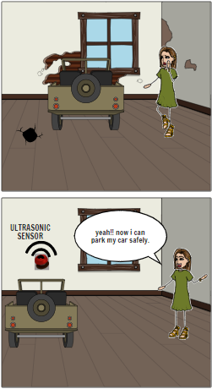

**Figure 1(Smart parking problem and solution)**

The flame senor used in the factory will alerts the responsible person in the mobile phone so he/she can take immediate action that will help to minimize fire affects.

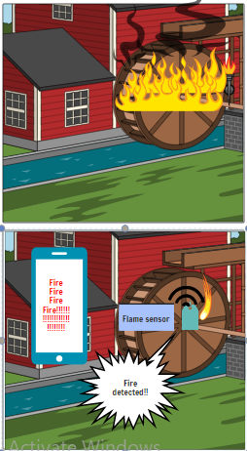

**Figure 2(problem and solution for Smart Fire alert)**

RFID sensor in the door is safe locking system that only allows authorized person enter and this solution will help in getting rid of unauthorized access in private room of the factory.

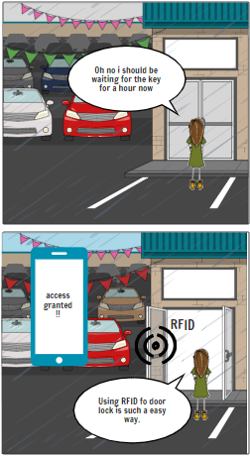

**Figure 3(Problem and Solution for smart door) )** (Clever Prototypes)

The light is setup with LDR sensor that will automatically turns off the light during day time that will reduce unnecessary costs.

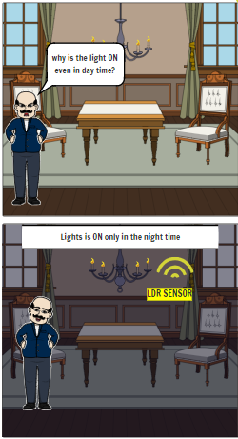

**Figure 4(problem and solution for smart Light)**

For water problem, there is smart water tank installed that will reduce the problem of water in the factory. Thus these solutions will reduce many problems of the factory.

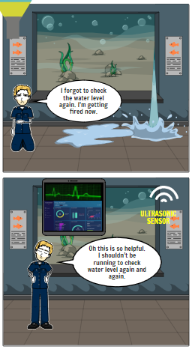

**Figure 5(Smart water level monitoring problem and solution)**

## Research and Plan

Various types of sensors, equipment, storage, designs, requirements, etc are needed to learn properly and get its ideas before implementing it. There are many similar types of sensors used for the same purposes, so we first search and perform detail studies about various sensors having similar mechanism and selected the suitable sensors that limits in our budget and requirements while developing prototype of smart factory. Similarly, there are many cloud storages available such as firebase, Ada fruit, Google sheet and even other database, that stores real-time data provided by sensors. While building the project, we choose Ada fruit and firebase simultaneously for storing the data provided by the sensors as we find it easy to use and it stores data fully. Even all the data can be accessed whenever and wherever when it is required so that we can tract every detail and help in making quick decision too. There is also automatic filling of water when the tank is empty, so that we don’t have to check water frequently and the data of water is also stored in database so that, the daily use of water can be known. Even there is fire alert system in the factory, so whenever there is fire detected in the factory, we can get alert and can take immediate action. The alerting system is done with the use of Blynk that sends notification in mobile. The parking sensor used in the factory will help the driver for safe parking, that reduces the minor accidents that may occurs while parking. The sensors used in parking detects the distance of the of the vehicle from the wall and if it gets close to the wall it starts beeping the sound so that the driver will get alert and be aware of casualty. The secured lock system with access to only authorized person is set on the door of the package store room so that the authorized person can only get access to the room with RFID card, the non-authorized person cannot enter the room that helps to get rid of package loss. The time of entry accessed and denied is stored in firebase storage and can be monitored through mobile self-build application. We searched for many light systems that can be used in the factory and we selected light system established with connection of LDR sensor so that, when it started getting dark or night time, the lights automatically turns on which help in reducing unnecessary use of light and minimize the electric bill.

For the purpose of planning, Microsoft project is used which is very reliable,

**Milestone**

|  |  |
| --- | --- |
| Milestone | Date |
| Project Initiation and Planning | 30 May 2019 |
| Project Development | 12 June 2019 |
| Implementation | 26 June 2019 |
| Project Handover and Closing | 12 July 2019 |

**Schedule**

Here is a detail description of how the work has been done, resources used and task assigned. With the use of Gantt Chart Tracking down of work can be shown. The Gantt chart of this project is shown below: -

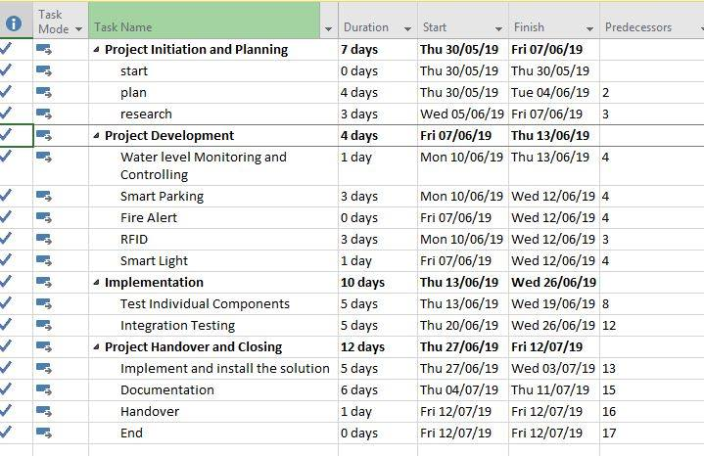

**Figure 6(Gantt chart for the project)**

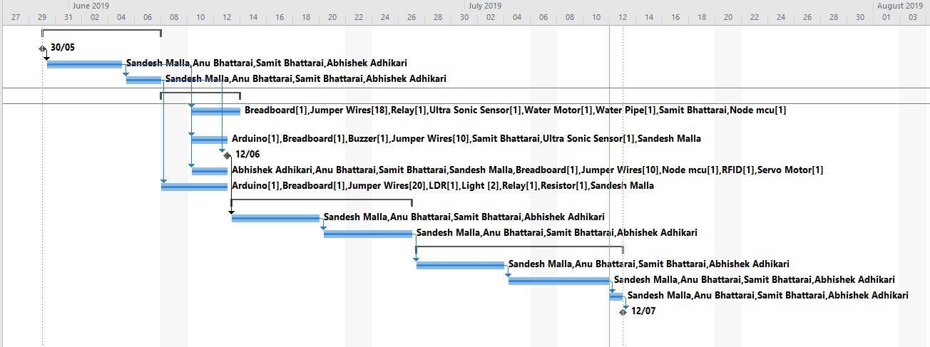

**Figure 7(Gantt Chart for the project)**

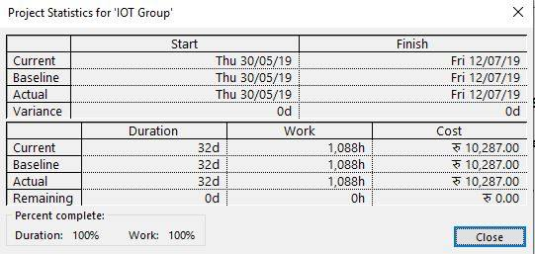

**Figure 8(Project Statistics)**

## Privacy and Ethics

One of the primary objectives was to develop a smart factory. While the research did not take place in the actual factory due to different constraints and in-depth inspection of relevant ethical issues was conducted and the result was a prototype of a smart factory. And alternative solution built with wood and plastics was run on simulated environment. This means ethical compliance was fulfilled. (Pdfs.semanticscholar)

## Risk management

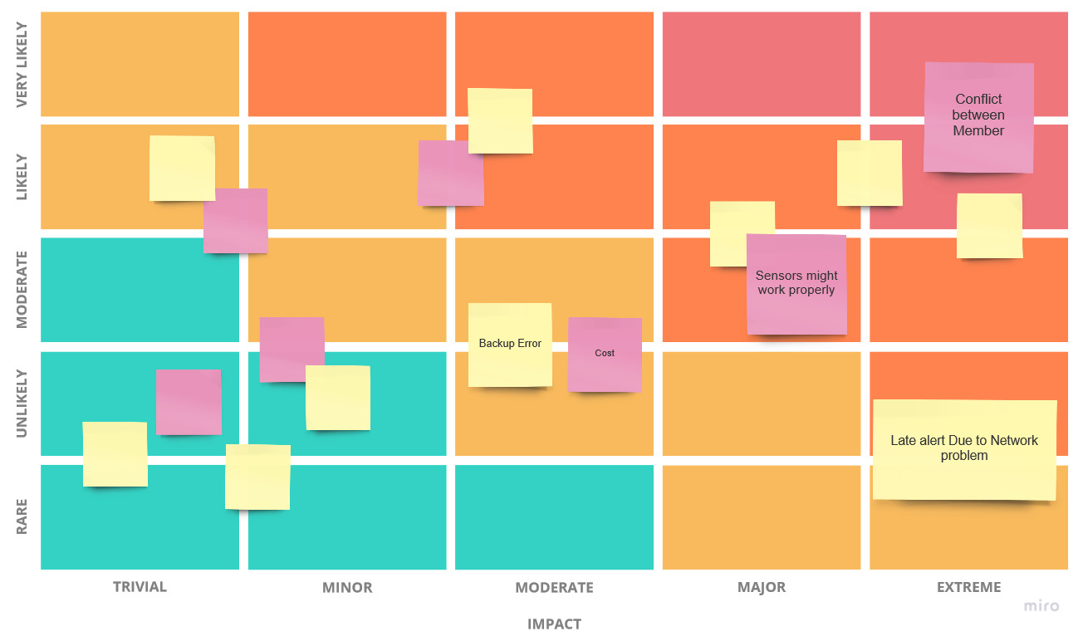

**Figure 9:(Risk matrix)**

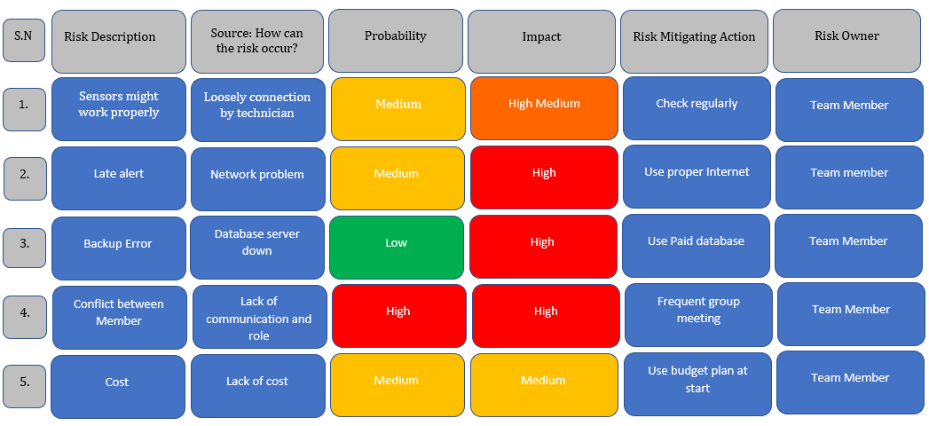

**Figure 10(Risk log)**

# System Design

Parts Used in this project are listed below: -

1. Nodemcu

Nodemcu works as microcontroller for controlling the all the sensor. It can be controlled with the use of WIFI or Local network.

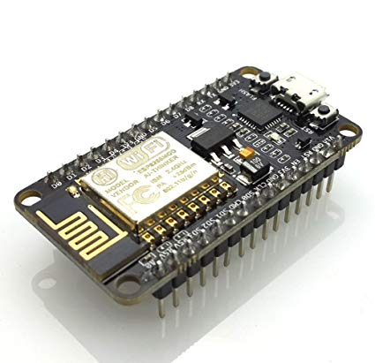

**Figure 11(Node MCU)**

1. Arduino Uno

In this project the Arduino Uno is used for controlling the sensor like ultrasonic sensor and LDR.

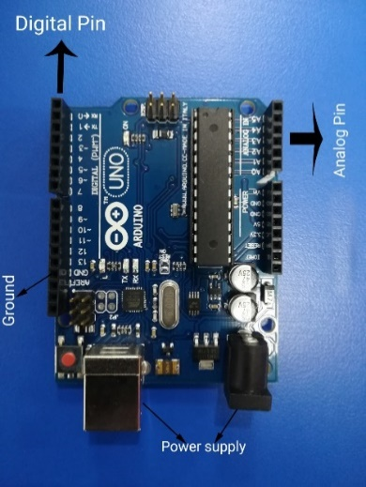

**Figure 12(Arduino Uno)**

1. LDR

LDR stands for Light dependent Resistors .it is used to indicate the presence or absence of the light.

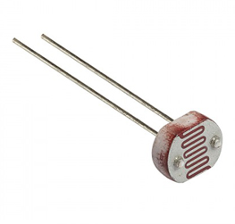

**Figure 13(LDR)**

1. Flame sensor

Here the flame sensor is used to detect and respond to the presence of the fire or flame .it is more accurate and faster than the other heat detecting sensor .

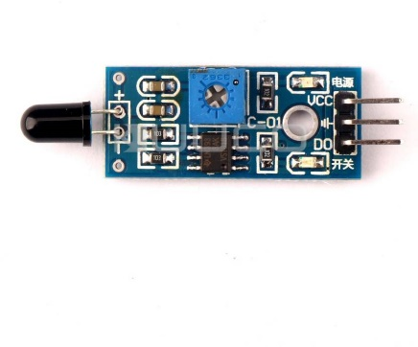

**Figure 14(Flame Sensor)**

1. Ultrasonic Sensor

Ultrasonic Sensor is used for measuring the distance of the object with use of sound waves .

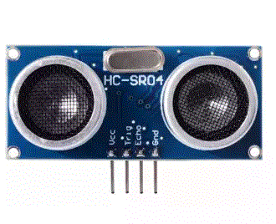

**Figure 15(Ultrasonic Sensor)**

1. Motor

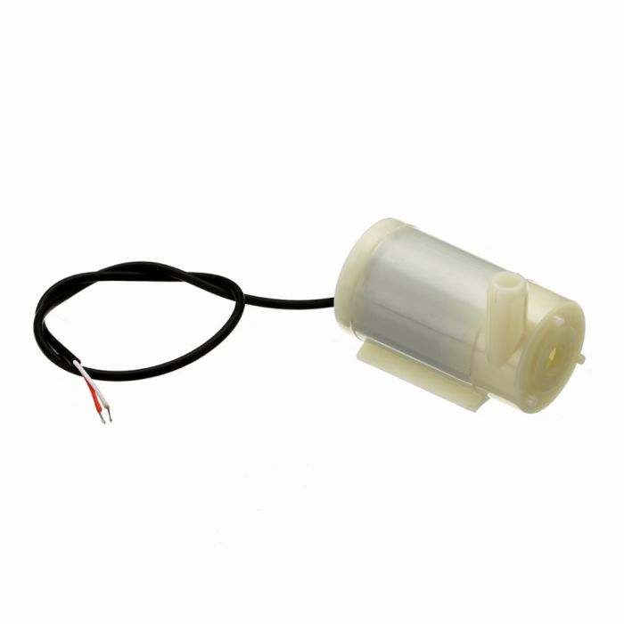

**Figure 16(Motor)**

1. Relay

Relay is used in the form of switch for actuating any operations.

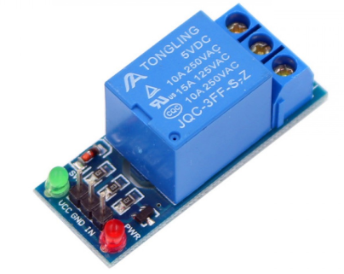

**Figure 17(Relay)**

1. RFID

Here RFID is used for protecting the factory from the unauthorized accessed. It gives the alert if detect that unauthorized User attempting for accesses to the factory premises.

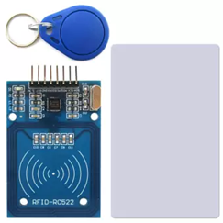

**Figure 18(RFID)**

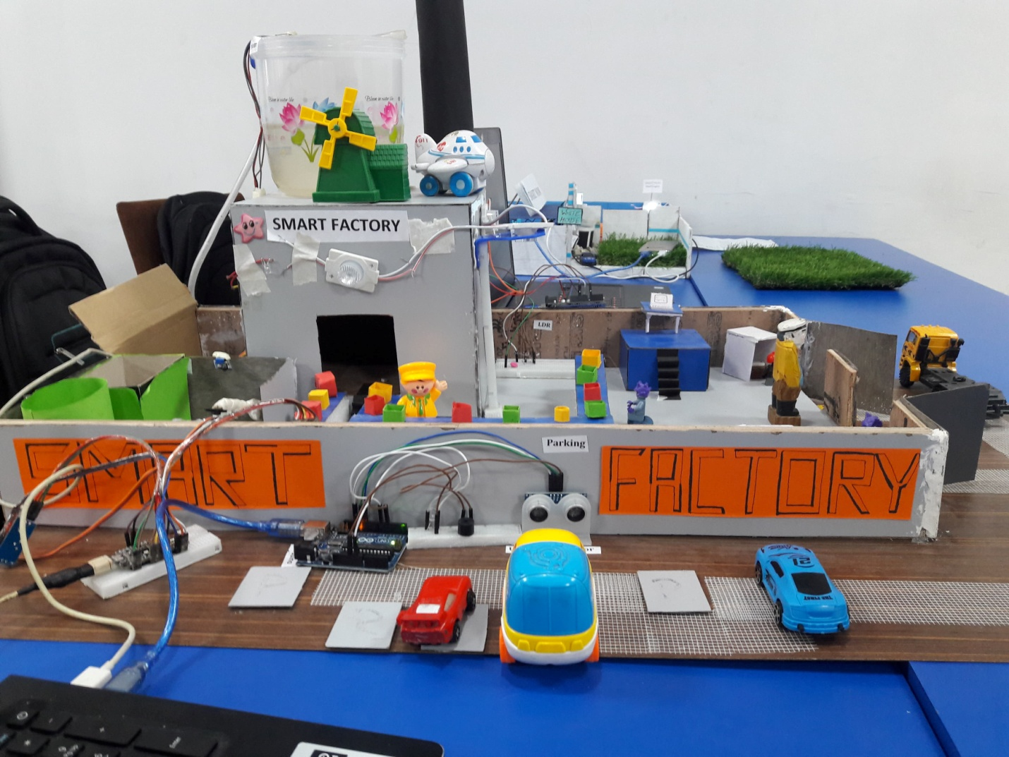

**Figure 19(Prototype for Smart Factory)**

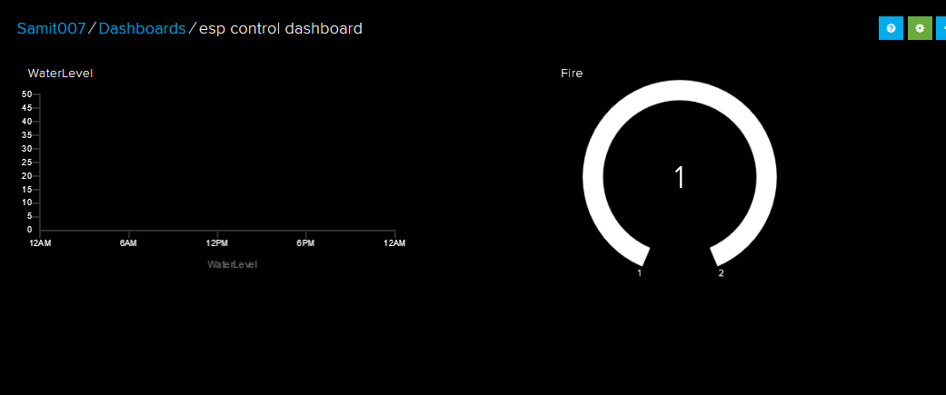

**Figure 20(Dashboard for the Smart Factory)**

## Working mechanism

For this project two controllers are used. Two controllers are Node mcu and Arduino Uno. Node mcu acts as a microcontroller and the entire sensor are connected to the node mcu. Node mcu use WIFI for transferring the data. For every sensor different pin is defined and power is given from the Ground pin. For power supply in the microcontroller the adapter is used. For storing the live data collected by the sensor adafruit is used which show and store the live data sensed by the sensor. The data is transferred from the nodemcu with help of WIFI.

For the smart factory it will have the features which are smart parking, RFID, Smart Light, Smart Water Level Monitoring Systems, Fire Detector.

* **Smart Parking**: - Through the use of ultrasonic sensor and Arduino Uno smart parking is developed. Smart parking gives alert to the driver which helps in decision making.
* **RFID**: - Here in this project RFID is used for not giving access to the unauthorized User. Here authorized user is provided with the secret key for opening the assets room. The detail of accessed and unauthorized trying to access the assets room will be shown in the mobile via app.
* **Smart Light**: - Here smart Light work with the use of LDR sensor which sense the intensity of the light and adjust resistance according to the intensity of light. With the use of LDR the light will only glow in the night time.
* **Smart Water Monitoring**: - With the use of nodemcu, motor, ultrasonic sensor this solution is implemented. Ultrasonic sensor detects the water level. It triggers the operation which will on the motor if there is no water in the tank. The data captured by the sensor is stored in the cloud through adafruit.
* **Fire alert**: - With the use of Flame sensor this solution is implemented. Flame sensor detect the presence and absence of the fire in the factory. If the flame sensor detects any kind of heat or fire in the factory it gives the alert which is shown in the mobile throughout the use of blynk app.

# Development

## Circuit Diagram

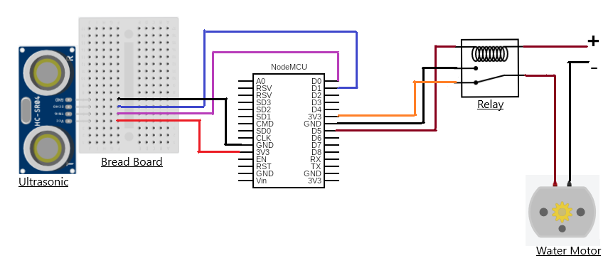

**Figure 21(Circuit diagram for Smart Water Level Monitoring Systems)**

Automatic water tank established with the connection through node MCU that automatically turns on the motor when the water level is low and turns off motor when the tank is filled. The data of water is also stored in cloud in Ada fruit storage that helps to monitor water usage in the factory.

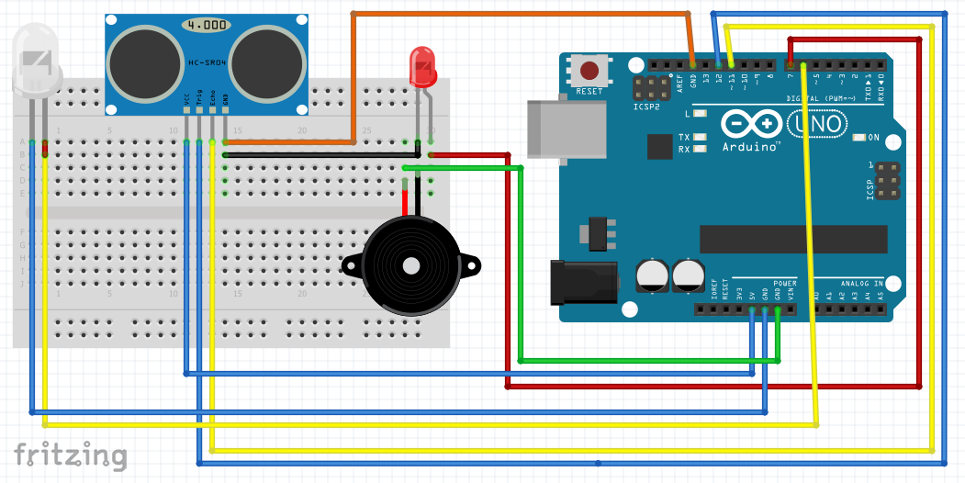

**Figure 22(Circuit Diagram For Smart Parking)**

The parking sensor is connected to Arduino board in the parking area, that beeps when vehicle is about to hit the wall so that rider/driver get immediate alert to prevent though casualty.

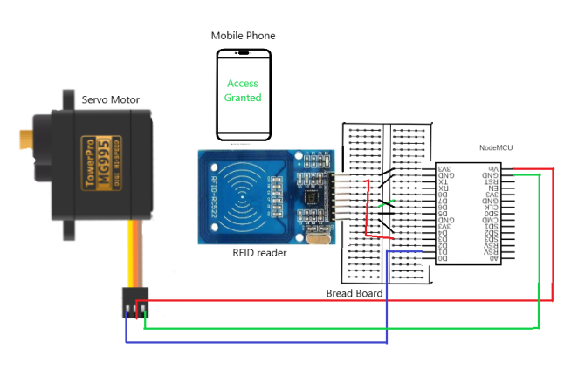

**Figure 23(Circuit diagram for RFID)**

In the smart factory, there is RFID card sensor set with use of node MCU, in the door which allows only authorized person to get access through. The data of access granted and accessed denied can be monitored through online Real time database and from mobile application.

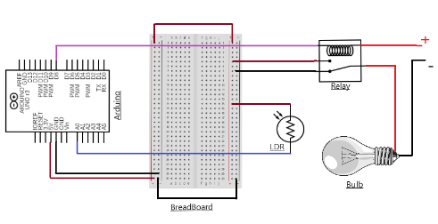

**Figure 24(Smart Light)**

The LDR sensor related lights are established in factory environments with the use of Arduino board so that it only lights when it is already night-time and turns off when there is no darkness.

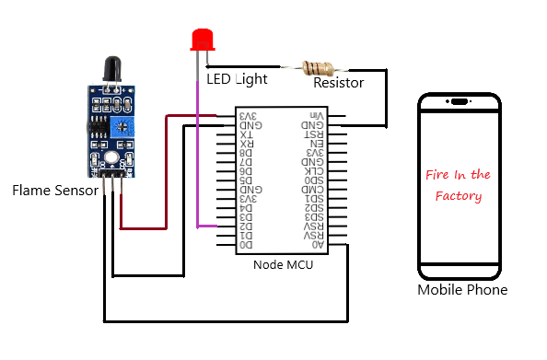

**Figure 25(Circuit diagram for Fire alert Systems)**

The fire sensor, Flame sensor connected through node MCU, is used in the package storeroom of the factory detects the fire and alerts the suitable person who can immediately take emergency action to prevent the disaster. The time of fire in the factory can be monitored through online database.

## Sketch

The sketch of the systems is given below: -

**Figure 26(Sketch for Smart Factory)**

**Figure 27(Sketch For Smart Factory)**

**Figure 29(Sketch for Fire alert)**

**Figure 30(Sketch for Fire alert)**

**Figure 31(Sketch for MQTT Connection)**

.

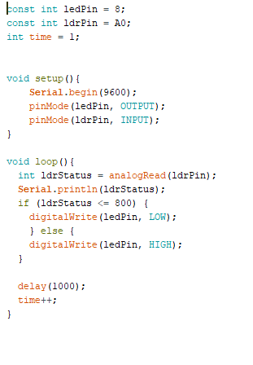

**Figure 32( Sketch for LDR)**

**Figure 33(Smart Parking)**

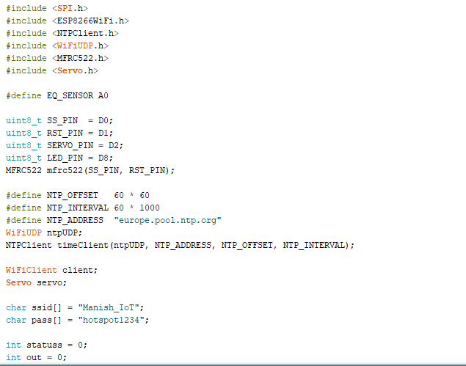

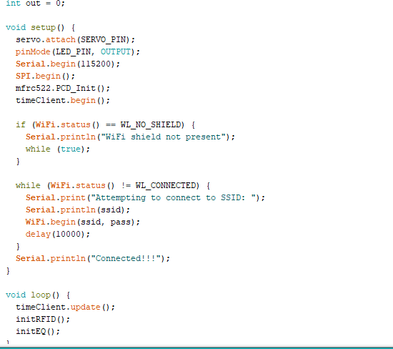

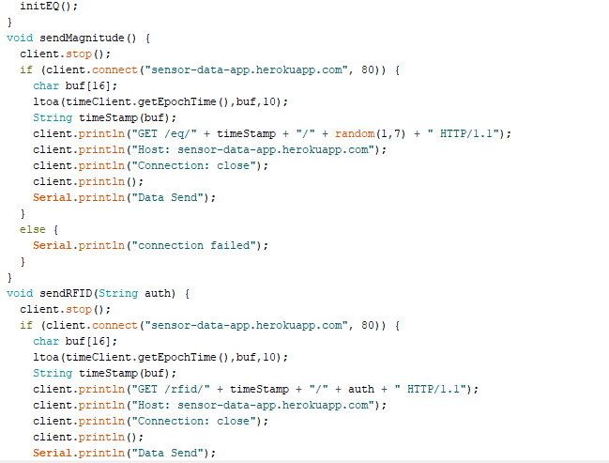

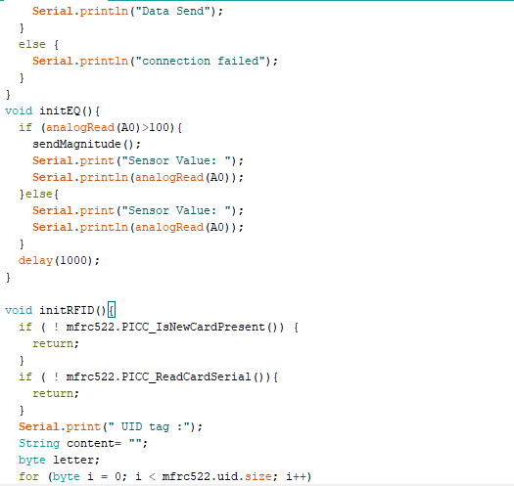

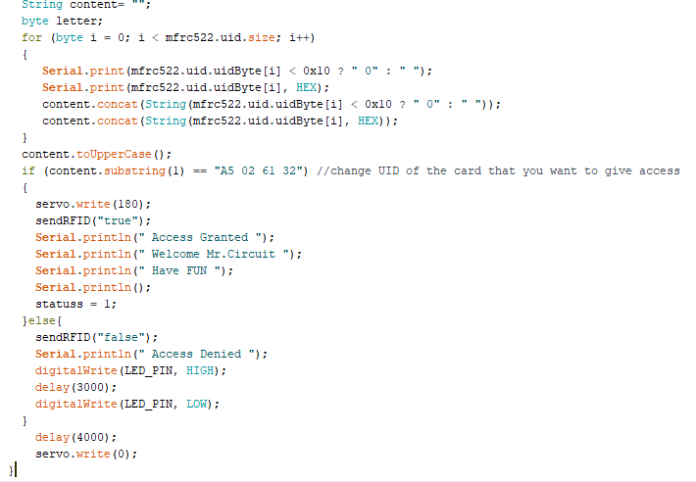

**Figure 34(Sketch For RFID**)

# Testing

Testing was performed in order to make sure that the prepared prototype actually works as per expectation or not. Initially, minor hurdles were faced and some technical errors in the Arduino IDE and Ada fruit library were witnessed. We overcome those issues with sufficient research and teachers were also helpful in this regard. Due to under average Wi-Fi connectivity, there was problem loading the data to the database most of the times. In the end we were able to observe a successful working prototype which worked well as per /our expectation when there is a good Wi-Fi connectivity. Also, we have recorded a video which clearly shows the actual test of our prototype.

# 

# Troubleshooting

**Data is not transferred to the cloud: -**

* Check whether the WIFI is working or not.
* Check the code if the Username and password of adafruit is correct or not.

**Alert system doesn’t work: -**

* Check whether the WIFI is working or not.
* Check whether the sensor is working or not.

**Data is not updated in real time: -**

• Check whether the WIFI Speed and connection.

• Check whether the Sensor is detecting the data or not.

**App doesn’t give the alert: -**

• Check whether the microcontroller is shown online or offline in the app.

• Check whether the password is change or refreshed.

# Future Work

App can be developed which show the live data of each and every sensor embedded in the factory. Controlling of the sensor through blynk app like controlling light from remote place. Development of the system which track the speed of vehicles carrying the assets of factory and tracking activities of the factory will be planned. Developing the app which show the quality of the goods and embedding the sensor like temperature , humidity for showing the live temperature and humidity of the factory .Embedding the tags to the machine which track the status of the machine and alert if the tags detects any kind of faults .

# Other application

Smart solutions (Smart parking, Fire Alert, Smart water Monitoring, Light and RFID) used in this project for making the smart system can be used in other field which are given below.

**For the Hospital same solution can be implemented: -**

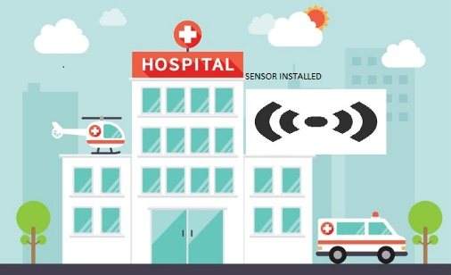

**Figure 35(Other Application)**

# Conclusions

In this way, a decision support system was developed with the use of different sensors and devices which helps to take a smart decision. Along with the smart decision, the data was also stored in the database. The stored data can be helpful to forecast data in the future which shall provide some good values to any business organizations that are using internet of things. The working prototype was also exhibited along with explanation of its features and good responses and feedbacks were gained which was a great motivation for us too.

# References

Deloitte Insights. (2019). *The smart factory*. [online] Available at: https://www2.deloitte.com/insights/us/en/focus/industry-4-0/smart-factory-connected-manufacturing.html [Accessed 6 Jul. 2019].

Pdfs.semanticscholar.org. (2019). [online] Available at: https://pdfs.semanticscholar.org/4832/7fd9a1837ac270d80c1b545e06e91afff436.pdf [Accessed 9 Jul. 2019].

Clever Prototypes, L. (2019). *Storyboard That: The World's Best Free Online Storyboard Creator*. [online] Storyboard That. Available at: https://www.storyboardthat.com/ [Accessed 10 Jul. 2019].

# Personal challenges

Working together as a group was very challenging for me. It was a new experience and was difficult to give equal contribution by all the team members. Planning and assigning the task was creating conflicts and lack of communication led us to problems like unmanaged planning, and dissatisfaction of some members. Not all the team members agreed in some decisions and we had different views on different topics. Also, development of the project did not go as planned at first.

Even if a lot of problems were faced, working in a team taught me to create a good cooperation, learn new views of other members and how to plan a single project combining four different ideas.